**CIS598**

**Plan Ver 2.0**

Written By: SIXIANG

21/2/2020

**Schedule**

**March:**

**One people:** Focus on basic functions and API version App, make it workable at least

**The other**: Focus AWS development and try to complete the training part

**April & May:**

If API version doesn’t go well, both focus on API version first (worst case)

If API version goes well, then complete the model version

**Develop a complete Product:**

Subtitle Generator with Speech Recognition

**Problem:**

1. Little AI / Web Develop / Speech Recognition Experience – Both of us
   1. Detail info (What we know):

AI – Python Sklearn dealing with sentiment data analysis

Web – Flask

Speech Recognition – Zero Experience

**Strategy:**

1. Mainly focus on developing a complete product with Baidu API
   1. Function need to be implemented

**Core:**

API Interaction – Sending audio, Get result

Subtitle related – Sperate Audio into piece, time recording, output

**Additional:**

Language Support

Ability of processing video / various types of audio

Realtime output

Make it a web application

**After that** - **Challenging:**

Make best effort to build our own model

Potential Solution:

Mozilla Deep Speech

1. Open Source
2. With enough guide on GitHub

Amazon LightSail

1. For training model
2. Maybe Web App

Training:

1. Free dataset provided by TensorFlow

**Problem**

1. Zero experience – both of us
2. Not sure we can make it or not
3. Seems that Amazon LightSail doesn’t provide GPU support (need to upgrade the service)
   1. 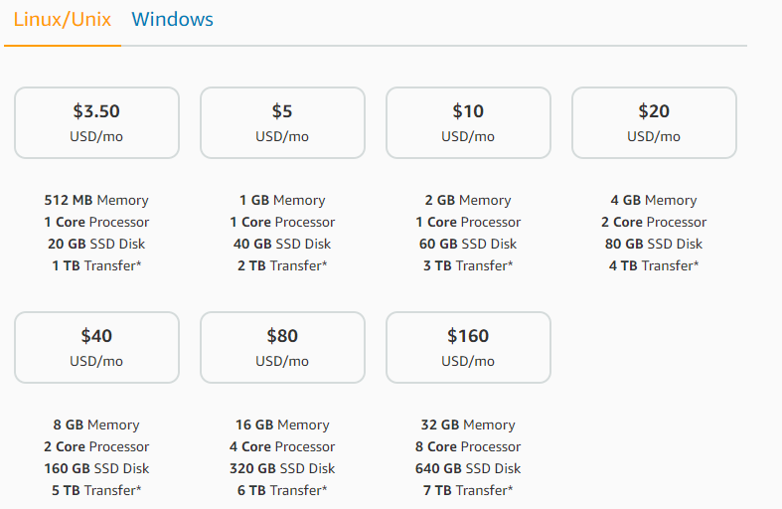Hardware problem – Only CPU, should be enough for training model
   2. Develop environment – Should be Linux
4. Any recommend material / guide?